***Antenna Composite Pattern Test Report***

|  |  |
| --- | --- |
| Manufacturer | JAGUAR WAVE |
| Sample Received | Feb.02,2024 |
| Start Test Date | Feb.02,2024 |
| Final Test Date | Feb.02,2024 |

**JAGUAR WAVE Technology Co,Ltd. Shenzhen Laboratory**

14F; TINNO HQ Building, Tongfa South Rd, Xili, Nanshan District, Shenzhen

Table Of Contents

1. Test Frequency 4

2. Testing Location 4

3. Test Facility and Configuration 5

4. Measured Values and Calculation of Maximum Gain Positions 6

5. Test Setup 7

6. Test Results 7

**History of this report**

|  |  |  |
| --- | --- | --- |
| **Version** | **Description** | **Issued Date** |
| 01 | Horn Antenna Test | Feb.02,2024 |
|  |  |  |
|  |  |  |
|  |  |  |
|  |  |  |
|  |  |  |
|  |  |  |
|  |  |  |
|  |  |  |
|  |  |  |
|  |  |  |
|  |  |  |
|  |  |  |
|  |  |  |

# Test Frequency

|  |  |
| --- | --- |
| **Band (GHz)** | **Test Frequency (GHz)** |
| 75-110 | 90 |
| 75-110 | 90.5 |
| 75-110 | 91 |
| 75-110 | 91.5 |
| 75-110 | 92 |
| 75-110 | 92.5 |
| 75-110 | 93 |
| 75-110 | 93.5 |
| 75-110 | 94 |
| 75-110 | 94.5 |
| 75-110 | 95 |
|  |  |
|  |  |
|  |  |

# Testing Location

|  |
| --- |
| **Testing Location** |
| JAGUAR WAVE Technology Co,Ltd. Shenzhen Laboratory |
| 14F; TINNO HQ Building, Tongfa South Rd, Xili, Nanshan District, Shenzhen |

|  |  |  |  |
| --- | --- | --- | --- |
| Test Condition | Test Engineer | Test Environment (°C / %) | Test Date |
| Radiated | Ck Yang | 23-24 / 50-55 | Feb.02,2024 |

Note:

Testing Site Information

Brand Name: NSI-700S-360

Dimension: 5m*4m*3m

Characteristic: Spherical Near-Field / Far-Field Chamber

# Test Facility and Configuration

**NSI-700S-360 SNF Scanner**

* Spherical system for stationary mm-wave antennas
* Well suited to applications above 10 GHz.
* Near-field and Far-field
* Multi-axis (3) high accuracy stepper motor
* Large enough to incorporate RF converter modules.
* Probe tip radius of roughly 20" (500 mm).
* All positioners contain integrated RF rotary joints to maximize cable phase stability during testing



1. **Measured Values and Calculation of Maximum Gain Positions**

max value position

|  |  |
| --- | --- |
| Frequency(GHz) | Gain(dBi) |
| 90 | 23.551 |
| 90.5 | 23.569 |
| 91 | 23.587 |
| 91.5 | 23.604 |
| 92 | 23.621 |
| 92.5 | 23.638 |
| 93 | 23.654 |
| 93.5 | 23.67 |
| 94 | 23.685 |
| 94.5 | 23.7 |
| 95 | 23.715 |

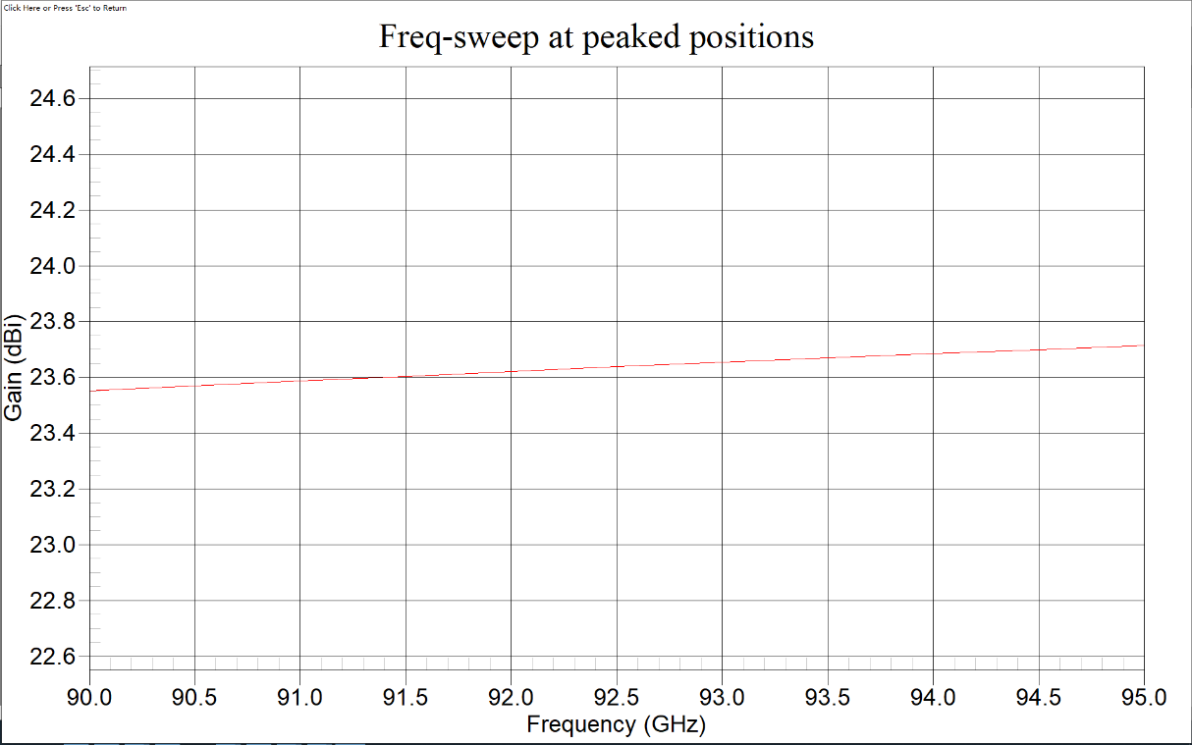

1. **Test Setup**

|  |
| --- |
| Test Position |
|  |
| Antenna Pattern Coordination |
|  |

Note: Photos of Test Position: Please refer to the test photos in the appendix

1. **Test Results**

* **Antenna Pattern**

(XZ plane) – Θ(0 -180)Φ(0) and Θ(0-180)Φ(180)

(YZ plane) – Θ(0 -180)Φ(90) and Θ(0-180)Φ(270)

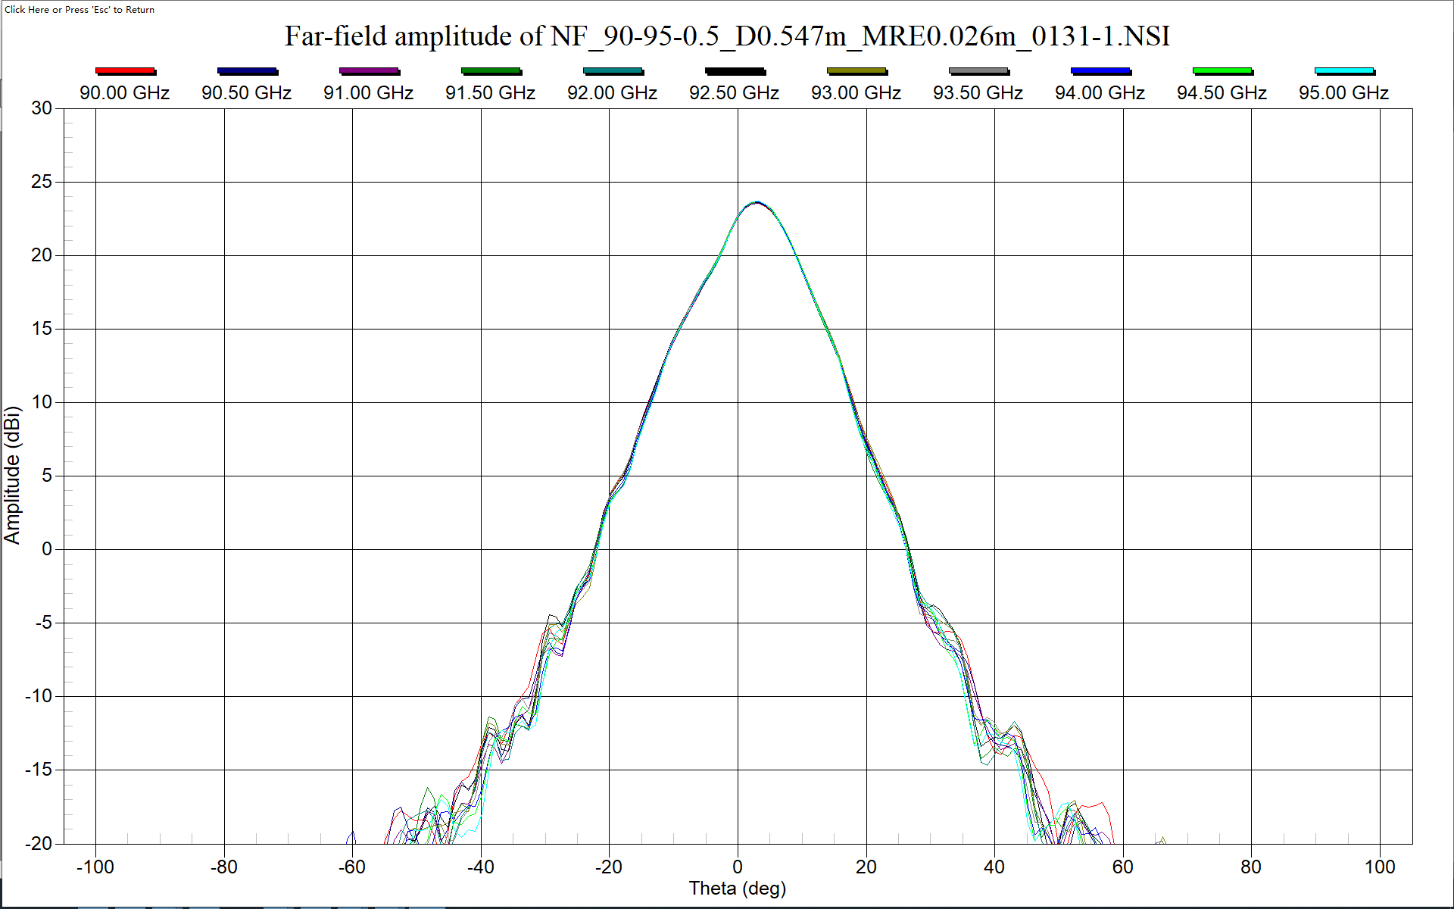

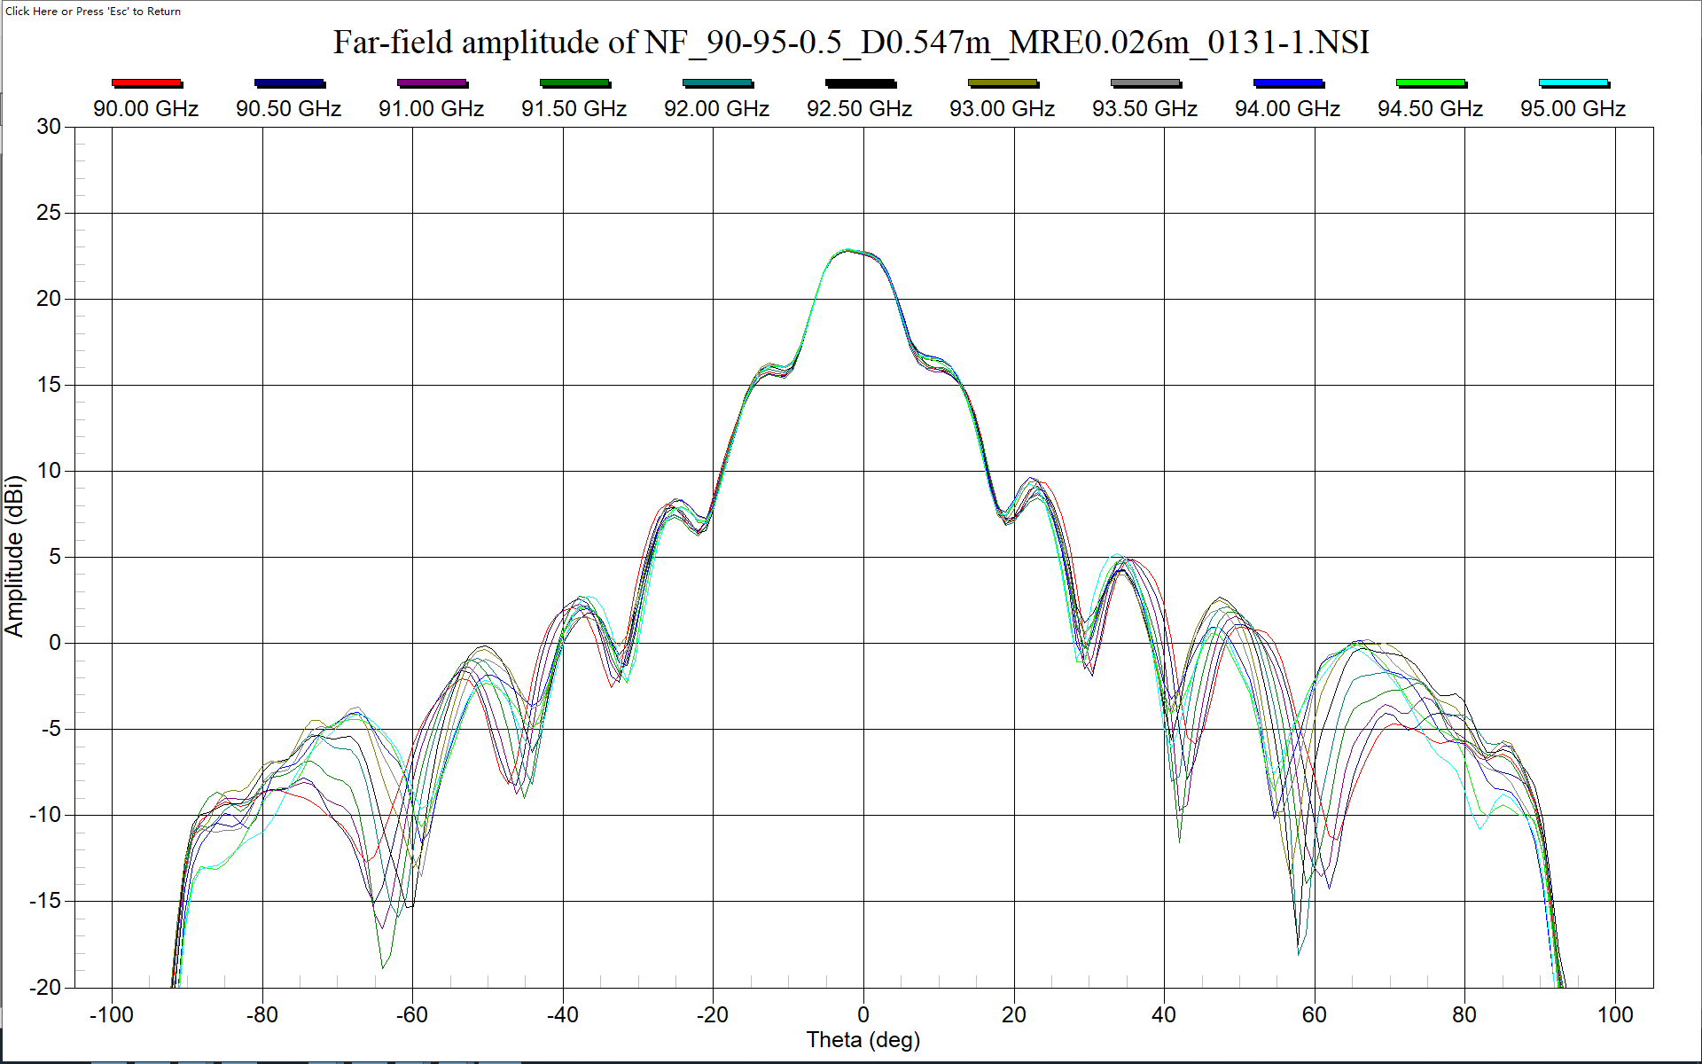

* **Test Photos**

